APPENDIXES
- Cover of the workbook design


2. Preface of the workbook design
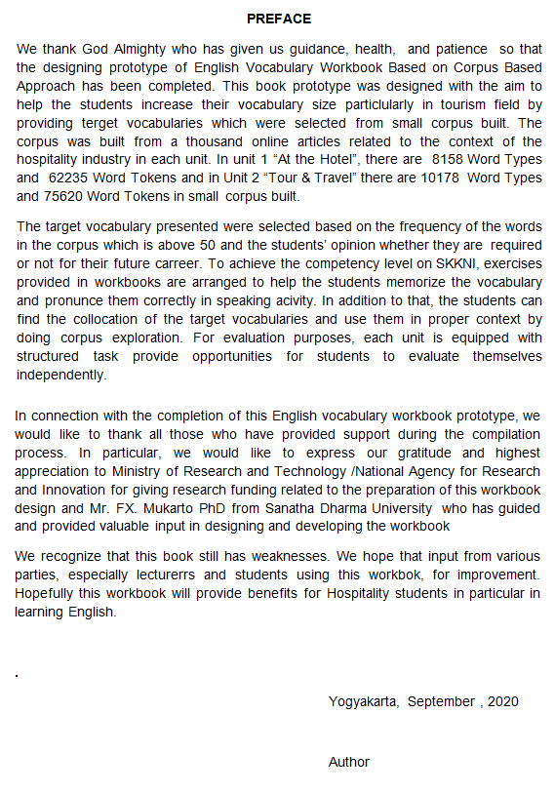

3. Table of contents of the Vocabulary Workbook
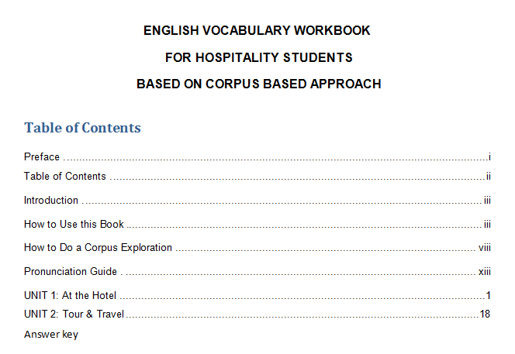

4. Material Expert Validation Results Data
No | Aspek Penilaian | Indikator | Nilai
1 | Relevansi | Materi dalam workbook sudah sesuai dengan tujuan pembelajaran dan kompetensi yang harus dikuasai mahasiswa | 4
1 | Relevansi | Target vocabulary dalam workbook sudah sesuai dengan kebutuhan mahasiswa Perhotelan. | 4
1 | Relevansi | Materi dalam workbook sudah sesuai dengan pendekatan berbasis corpus yaitu inductive learning | 5
1 | Relevansi | Materi sudah sesuai untuk meningkatkan penguasaan vocabulary mahasiswa | 5
1 | Relevansi | Materi dalam workbook dapat didemonstrasikan oleh mahasiswa dengan mudah | 4
2 | Kelengkapan Sajian | Kelengkapan isi workbook sudah lengkap | 5
3 | Keakuratan dan Kejelasan | Urutan kegiatan pembelajaran jelas dan mudah diikuti | 5
3 | Keakuratan dan Kejelasan | Penjelasan pelaksanaan latihan dalam workbook sudah jelas | 5
3 | Keakuratan dan Kejelasan | Keakuratan penggunaan tata Bahasa | 5
3 | Keakuratan dan Kejelasan | Bahasa yang digunakan tidak menimbulkan multi tafsir | 5
4 | Kesesuaian sajian dengan tuntutan pembelajaran yang terpusat pada siswa | Konsep kegiatan dalam workbook sudah berpusat pada mahasiswa serta mengembangkan kemampuan berfikir mahasiswa | 5
4 |  | Mendorong rasa keingintahuan mahasiswa | 5
4 |  | Mendorong terjadinya interaksi mahasiswa | 5
4 |  | Mendorong siswa membangun pengetahuannya sendiri | 5
4 |  | Mendorong siswa belajar secara kelompok | 5
 |  | Jumlah | 72
 |  | Rata-rata | 4,8

5. Media Expert Validation Results Data
No | Aspek Penilaian | Indikator | Nilai
1. | Tampilan Umum | Desain media sesuai dengan pendekatan berbasis linguistik korpus | 5
1. | Tampilan Umum | Desain media menarik dilihat | 4
1. | Tampilan Umum | Desain media menyajikan contoh riil pendekatan berbasis linguistik korpus | 5
2. | Tampilan Khusus | Pemilihan warna dalam media menarik | 4
3. | Penyajian Media | Apakah media yang disajikan sudah sesuai dengan kebutuhan mahsiswa | 5
3. | Penyajian Media | Apakah media yang disajikan sudah sesuai dengan pendekatan berbasis linguistik korpus | 5
3. | Penyajian Media | Pada gambar di workbook terdapat keterangan | 5
 |  | Jumlah | 33
 |  | Rata-rata | 4,7

6. The students’ responses on the practicality of theworkbook.

Kode Siswa | Nomor angket |  |  |  |  |  |  |  |  |  | Jumlah
Kode Siswa | 1 | 2 | 3 | 4 | 5 | 6 | 7 | 8 | 9 | 10 | Jumlah
Kode Siswa | Nilai |  |  |  |  |  |  |  |  |  | Jumlah
S1 | 4 | 3 | 4 | 3 | 4 | 3 | 4 | 4 | 4 | 3 | 36
S2 | 3 | 3 | 3 | 3 | 3 | 3 | 4 | 3 | 4 | 3 | 32
S3 | 3 | 3 | 3 | 3 | 3 | 3 | 4 | 3 | 4 | 3 | 32
S4 | 3 | 3 | 3 | 3 | 3 | 3 | 3 | 3 | 3 | 3 | 30
S5 | 4 | 3 | 3 | 3 | 3 | 3 | 3 | 3 | 3 | 3 | 31
S6 | 3 | 3 | 3 | 3 | 3 | 3 | 3 | 3 | 3 | 3 | 30
S7 | 3 | 3 | 3 | 3 | 3 | 3 | 3 | 3 | 4 | 3 | 31
S8 | 4 | 3 | 4 | 3 | 2 | 3 | 4 | 3 | 3 | 3 | 32
S9 | 3 | 3 | 3 | 3 | 3 | 3 | 3 | 3 | 3 | 3 | 30
S10 | 2 | 3 | 2 | 2 | 2 | 3 | 3 | 2 | 3 | 2 | 24
S11 | 3 | 3 | 3 | 3 | 3 | 3 | 3 | 3 | 3 | 3 | 30
S12 | 3 | 3 | 3 | 3 | 3 | 3 | 3 | 3 | 3 | 3 | 30
S13 | 2 | 3 | 2 | 3 | 4 | 3 | 2 | 2 | 3 | 3 | 27
S14 | 3 | 3 | 3 | 3 | 3 | 3 | 3 | 4 | 3 | 3 | 31
S15 | 2 | 3 | 3 | 3 | 4 | 3 | 3 | 3 | 2 | 2 | 28
S16 | 4 | 3 | 2 | 2 | 3 | 3 | 4 | 3 | 3 | 3 | 30
S17 | 3 | 3 | 4 | 3 | 4 | 3 | 4 | 4 | 3 | 4 | 35
S18 | 3 | 3 | 4 | 3 | 3 | 3 | 4 | 3 | 3 | 3 | 32
S19 | 3 | 3 | 2 | 3 | 3 | 3 | 2 | 3 | 3 | 3 | 28
S20 | 3 | 3 | 4 | 3 | 4 | 4 | 4 | 4 | 3 | 3 | 35
S21 | 3 | 3 | 3 | 3 | 3 | 3 | 3 | 3 | 3 | 3 | 30
S22 | 3 | 3 | 3 | 4 | 3 | 3 | 3 | 3 | 3 | 3 | 31
S23 | 4 | 4 | 3 | 3 | 3 | 3 | 4 | 4 | 3 | 4 | 35
S24 | 3 | 4 | 4 | 3 | 3 | 4 | 4 | 3 | 3 | 3 | 34
S25 | 4 | 4 | 4 | 4 | 3 | 3 | 4 | 4 | 4 | 4 | 38
S26 | 4 | 4 | 3 | 4 | 3 | 4 | 4 | 4 | 4 | 4 | 38
S27 | 4 | 4 | 3 | 3 | 3 | 2 | 3 | 3 | 3 | 3 | 31
S28 | 3 | 3 | 3 | 3 | 4 | 3 | 3 | 3 | 3 | 3 | 31
S29 | 4 | 4 | 4 | 3 | 4 | 3 | 3 | 4 | 4 | 4 | 37
S30 | 4 | 3 | 3 | 3 | 3 | 3 | 4 | 4 | 4 | 4 | 35
S31 | 3 | 3 | 3 | 3 | 3 | 3 | 3 | 3 | 3 | 3 | 30
S32 | 3 | 3 | 3 | 3 | 3 | 3 | 3 | 3 | 3 | 3 | 30
S33 | 3 | 3 | 3 | 3 | 3 | 4 | 4 | 3 | 3 | 4 | 33
S34 | 3 | 3 | 3 | 3 | 3 | 3 | 3 | 3 | 3 | 3 | 30
S35 | 3 | 4 | 3 | 3 | 3 | 4 | 4 | 4 | 3 | 4 | 35
S36 | 3 | 3 | 3 | 3 | 3 | 3 | 3 | 3 | 3 | 3 | 30
S37 | 2 | 3 | 2 | 3 | 3 | 2 | 3 | 2 | 2 | 3 | 25
S38 | 4 | 3 | 4 | 3 | 3 | 3 | 4 | 4 | 4 | 4 | 36
S39 | 3 | 3 | 4 | 3 | 4 | 3 | 4 | 4 | 4 | 4 | 36
S40 | 3 | 3 | 3 | 3 | 3 | 3 | 4 | 4 | 3 | 3 | 32
S41 | 3 | 3 | 3 | 3 | 3 | 3 | 3 | 3 | 3 | 3 | 30
S42 | 3 | 3 | 2 | 3 | 2 | 3 | 3 | 3 | 3 | 3 | 28
S43 | 3 | 3 | 3 | 3 | 3 | 3 | 3 | 3 | 3 | 4 | 31
S44 | 2 | 2 | 1 | 3 | 3 | 2 | 3 | 2 | 2 | 3 | 23
S45 | 3 | 2 | 3 | 3 | 2 | 2 | 3 | 3 | 3 | 3 | 27
S46 | 4 | 3 | 3 | 3 | 3 | 3 | 4 | 3 | 3 | 4 | 33
S47 | 4 | 3 | 3 | 3 | 3 | 3 | 3 | 3 | 3 | 4 | 32
S48 | 2 | 3 | 2 | 3 | 3 | 3 | 2 | 4 | 3 | 3 | 28
S49 | 3 | 3 | 3 | 3 | 3 | 3 | 3 | 4 | 3 | 3 | 31
S50 | 3 | 3 | 3 | 3 | 3 | 3 | 3 | 3 | 3 | 3 | 30
Total | 157 | 155 | 151 | 151 | 154 | 151 | 166 | 161 | 157 | 161 | 1564
Rata-rata | 3,14 | 3,1 | 3,02 | 3,02 | 3,08 | 3,02 | 3,32 | 3,22 | 3,14 | 3,22 | 31,28

7. Pre-test and post-test score

DAFTAR NILAI PRE-TEST & POST-TEST
Kode Nama Mahasiswa | Nilai Pre-test | Nilai Post-test
S1 | 25 | 30
S2 | 30 | 35
S3 | 20 | 40
S4 | 20 | 65
S5 | 20 | 80
S6 | 35 | 100
S7 | 40 | 50
S8 | 15 | 30
S9 | 25 | 40
S10 | 20 | 25
S11 | 35 | 25
S12 | 15 | 70
S13 | 35 | 70
S14 | 25 | 30
S15 | 10 | 75
S16 | 45 | 85
S17 | 40 | 80
S18 | 25 | 60
S19 | 10 | 20
S20 | 50 | 45
S21 | 40 | 90
S22 | 50 | 60
S23 | 25 | 60
S24 | 60 | 100
S25 | 75 | 75
S26 | 60 | 45
S27 | 35 | 45
S28 | 65 | 100
S29 | 0 | 75
S30 | 15 | 80
S31 | 85 | 100
S32 | 50 | 75
S33 | 30 | 60
S34 | 20 | 80
S35 | 15 | 20
S36 | 55 | 70
S37 | 65 | 85
S38 | 30 | 65
S39 | 10 | 10
S40 | 10 | 60
S41 | 50 | 60
S42 | 15 | 60
S43 | 35 | 50
S44 | 55 | 65
S45 | 25 | 35
S46 | 10 | 25
S47 | 80 | 80
S48 | 20 | 20
S49 | 20 | 30
S50 | 30 | 45
S51 | 25 | 80
S52 | 15 | 20
Jumlah | 1715 | 2980
Rata-rata | 32,98 | 57,31

