PUBLIC SERVICE TRANSFORMATION AND AGRIBUSINESS MARKETING: INNOVATION ANALYSIS OF MAGESTY PUBLIC SERVICE PORTAL AND PLAZA TANI IN MAGELANG CITY
Sri Mulyani¹, Retno Dewi Pramodia Ahsani², dan Catur Wulandari³
^{1,2,3}Public of Administation, Political and Social Science, Tidar University, Indonesia
hartomomulyani@gmail.com

ABSTRAK
Penelitian ini bertujuan untuk menganalisis transformasi pelayanan publik dan pemasaran agribisnis melalui inovasi Magesty Public Services Portal dan Plaza Tani di Kota Magelang. Penelitian ini dilakukan dengan menerapkan metode mix-method yaitu dengan pendekatan kualitatif dan kuantitatif. Teknik pengumpulan data melalui wawancara dan survei. Subjek penelitian adalah masyarakat pengguna aplikasi, pelaku usaha, dan Organisasi Perangkat Daerah di Kota Magelang yang menggunakan layanan Magesty Public Services Portal dan Plaza Tani. Hasil penelitian menunjukkan bahwa transformasi pelayanan publik dan pemasaran agribisnis melalui inovasi Magesty Public Services Portal dan Plaza Tani memberikan dampak positif bagi masyarakat dan pelaku usaha di Kota Magelang. Rekomendasi yang diberikan adalah perlu adanya peningkatan kualitas layanan dan promosi yang lebih efektif untuk meningkatkan partisipasi masyarakat dan pelaku usaha dalam menggunakan layanan tersebut.

Kata kunci; transformasi, pelayanan publik, pemasaran agribisnis, inovasi, Magesty Public Services Portal, Plaza Tani.
ABSTRACT
This research aims to analyze the transformation of public services and agribusiness marketing through the innovation of the Magesty Public Services Portal and Plaza Tani in Magelang City. This research used a mixed method with qualitative and quantitative approaches—data collection techniques through interviews and surveys. The research subjects were application users, business actors, and Regional Apparatus Organizations in Magelang City who use the Magesty Public Services Portal and Plaza Tani services. The results showed that the transformation of public services and agribusiness marketing through the Magesty Public Services Portal and Plaza Tani innovation positively impacted the community and business actors in Magelang City. The recommendations are the need to improve service quality and more effective promotion to increase community and business participation in using these services.

Keywords: transformation, public services, agribusiness marketing, innovation, Magesty Public Services Portal, Plaza Tani.

INTRODUCTION
Information and communication technology has changed people's lives and businesses (Yunani, 2022). Public service modernization and agriculture industry growth depend on digital transformation (Arkana, 2018). In this context, analyzing the Magesty Public Services Portal and Plaza Tani in Magelang City's transformation of public services and agro marketing is important. Magelang City's agricultural potential and local culture make it an intriguing place to test advances in these two industries.
Public service is a key government pillar that meets community requirements (Prayitno & Subagiyo, 2018). Public service includes government and public institution services to citizens (Darwis et al., 2023). It involves government-public interactions in population administration, licensing, health, education, and social services. Public services are increasingly important for public satisfaction and governance efficiency in the digital age. Public demand for rapid, transparent, accessible services drives a deep shift in public service organizations (Hub, 2021; Türkeș et al., 2021).
People's welfare and trust in government depend on public service excellence. Public services are accessible, transparent, and responsive to community needs and ambitions (Dayaram et al., 2020). In response to modern demands, public service transformation uses information and communication technology to reduce bureaucracy, increase efficiency, and strengthen government-citizen relations (Aggarwal, 2022; Walia, 2020). However, public service change must address diversity and accessibility. Technology must be adopted with attempts to benefit all levels of society, even those with less experience. Successful public service transformation requires a holistic approach that includes the digital divide and societal concerns.
Innovative solutions like Magelang City's Magesty Public Services Portal show the local government's commitment to constructive change in the face of complicated bureaucratic processes. The platform simplifies accessing crucial information, submitting requests, and receiving public services for citizens. Magelang's digital transformation shows how public service transformation may meet society's changing needs and maximize government technology's benefits.
Agriculture is crucial to the regional economy in agriculturally rich cities like Magelang City. Marketing agriculture products and linking producers with consumers can be complicated. Plaza Tani is an invention that brings producers and consumers together in an actual area. Plaza Tani educates customers about local agriculture and boosts agribusiness in the region.
Magelang City has great potential to combine modern public service transformation with sustainable agriculture development. The city shows its dedication to good change by implementing the Magesty Public Services Portal and Plaza Tani idea, which uses technology and creativity to optimize two crucial sectors. Magelang wants to boost regional competitiveness, investment, and company growth by improving public services. However, a more thorough investigation is needed to comprehend these advances' significant effects. An in-depth analysis will show how this change supports local development and benefits all Magelang City stakeholders by considering the impact on the community, government, and enterprises.
The Magesty Public Services Portal and Plaza Tani innovations in Magelang City must balance technology and community participation to transform public services and agriculture commercialization. Technology can streamline operations and boost efficiency, but community involvement is crucial. Public agencies must address the use of technology by populations with different digital literacy levels to ensure everyone is included. In agriculture marketing, sustaining Plaza Tani's direct engagement between producers and consumers in the face of Internet transactions is difficult (Grimm, 2022; Setthasuravich & Kato, 2020). Thus, the success of this change depends on local governments and agricultural operators integrating technology to encourage community and commercial participation.
This research innovatively integrates public service transformation and agricultural marketing into one holistic analysis. The Magesty Public Services Portal and Plaza Tani in Magelang City demonstrate how technology and marketing may work together to boost local economic growth and community welfare. This research is unusual because it is directly applied at the municipal level, which accurately depicts the local effects of transformation. This research may help other cities and areas tailor comparable solutions to their needs. This research is new in its multidisciplinary analysis and practical solutions that diverse regions might use to sustain public service and agricultural marketing change.
This Magelang City public services and agriculture marketing transformation study has significant ramifications. This research can determine how well these innovations achieve their goals by studying how Magesty Public Services Portal and Plaza Tani connect with the community and agriculture industry. This research suggests technological and marketing ideas for other similar regions. This research analyzes the transition of public services through the Magesty Public Services Portal and agriculture marketing through Plaza Tani in Magelang City. This analysis will show how these innovations boost public service efficiency and local agribusiness. This research can help politicians, businesspeople, and the community maximize digital transformation and innovative marketing for Magelang City's development.

METHODOLOGY
Qualitative and quantitative methodologies examine public service change in the digital age and its interaction with agribusiness marketing. The case study analysis will examine Magesty Public Services Portal's public service transformation and its impact on Plaza Tani's agriculture marketing in Magelang City. The research population includes agribusiness actors at Plaza Tani in Magelang City and Magesty Public Services Portal users. Age, gender, and education will be considered while selecting the sample to ensure perspective diversity.
Several methods collect data. A poll will assess public service portal users' satisfaction, efficiency, and service perception. Local government and agribusiness actors will be interviewed to understand Plaza Tani and public service change. Secondary data like local government performance reports and Plaza Tani sales statistics will augment the analysis. Statistics will be used to define respondent profiles and evaluate hypotheses using inferential analysis. We'll use thematic coding and clustering to examine qualitative interview data. Information from numerous sources will be triangulated to improve research validity. NVivo 12 Plus will analyze qualitative data from interviews and documents about Magelang City's digital public service transformation and agricultural marketing.
Public service transformation and agriculture marketing data analysis using NVivo 12 Plus involves several steps. The first step is importing interviews, policy documents, reports, and other pertinent data into NVivo 12 Plus (Salahudin et al., 2020). Coders will categorize the imported data. For example, "Public Service Transformation," "Agribusiness Marketing," "Technology Integration," "Service Effectiveness," and others help uncover patterns, themes, and relationships (Swygart-Hobaugh, 2019). After categorizing relevant categories into themes, data can be better understood and organized. For instance, "Impact of Integration" may contain "Effect on Accessibility" and "Increased Consumer Satisfaction" (Zhang et al., 2022).
NVivo 12 Plus was used for theme analysis after categorical grouping. Using keyword phrases or code characteristics involved finding and exploring themes in the data transcriptions (Hudaefi & Beik, 2021). Results from theme analysis are utilized to build data patterns and findings. Diagrams and maps in NVivo 12 Plus help explain and interpret analysis results (Rossolatos, 2019)—Triangulate data with NVivo 12 Plus to increase the research's validity. Interview transcripts and imported documents are compared and combined to strengthen study results. This NVivo 12 Plus program helped researchers examine their data (Wang & Zhou, 2023). The analysis will reveal the efficacy of public service reform and agricultural marketing integration. Explore the findings' practical applications to improve public service delivery and agricultural product marketing. Policies will also improve public-agribusiness relations in the digital age. The figure shows this study method's framework.
.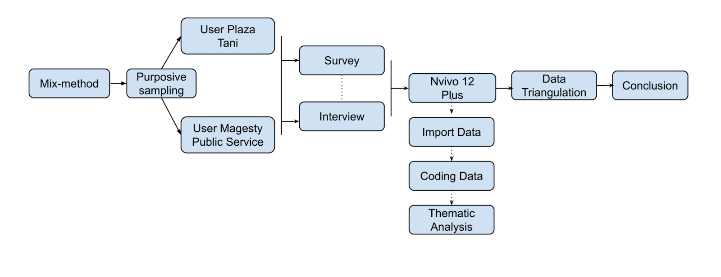
Figure. 1 Research methodology framework
DISCUSSION
Accessibility of Public Service Innovation
Public service accessibility and information provision are essential to government transparency and quality (Moseley, 2023). Accessibility ensures citizens can easily access government services and facilities, forming the basis of social justice and equality (Ostrom & Ostrom, 2019). Digitization of public services has become crucial to enhance accessibility, especially as technology advances. Government efforts to create user-friendly online platforms are pivotal in increasing public access. Evaluating information provision is equally crucial for government transparency (Stępniak et al., 2019). Clear, accessible information, including quality, dissemination speed, and data delivery transparency, is vital for a functioning democracy. Information transparency is foundational for public understanding of government actions, and comprehensive evaluation ensures effective communication.
Magelang City's top ranking nationwide in the Ombudsman RI Public Service Standards Compliance Assessment in 2022 reflects the local government's commitment to enhancing public service accessibility (Fauziah & Mahendradi, 2021; Latifah, 2022). The city's investment in public service digitization has contributed to its success, creating a user-friendly web platform for citizens to access information and services easily(Twizeyimana & Andersson, 2019). Furthermore, Magelang City prioritizes information transparency by providing clear and accessible data on government programs and projects (Pramono, 2020). Regular solicitation of community input and involvement in planning and reviewing public services fosters government-community relations, promoting accessibility and trust. This concerted effort ensures that public services in Magelang City are not only accessible but also transparent and responsive to community needs.
Table 1. Accessibility of Public Services in Magelang City in 2023
No. | Public Service Accessibility | Type of Public Service
1 | Online Public Services | * Application for business license  * Application for domicile certificate  * Application for identity card (KTP)  * Birth certificate application  * Application for death certificate  * Application for death certificate  * Application for moving certificate  * Application for certificate of incapacity  * Application for business certificate
2 | Provision of Public Service Mall (MPP) | * Online queuing service  * Information and complaint services  * Disability services  * Children's playroom service  * Lactation room service  * Rest room service
3 | Inclusive Public Service Provision | * Ramp for accessibility  * Wheelchair  * Special toilets for people with disabilities  * Sign language interpreters  * Information and complaint services that are easily accessible to people with disabilities
Source; (Hadiyono et al., 2023; Latifah, 2022; Pramono, 2020)
Table 1 shows the accessibility of public services provided by the Magelang City government. One of the efforts made by the Magelang City Government to improve the accessibility of public services is by providing public services online (Prasetyo & Arifin, 2018). This is done to make it easier for people to access public services, especially for people outside the city who do not have time to come to the public service office. The Magelang City government developed the accessibility of online public services with the Magesty Public Services Portal (MPSP) innovation.
Magesty Public Service Portal is an important innovation in transforming public services in Magelang City. It shows the government's seriousness in utilizing information technology to provide better services to its citizens. MPSP is an online platform that has created a fundamental change in how public services are accessed and received by the citizens of this city. MPSP brings various public services online, removing the barriers often associated with physical visits to public service offices. Citizens no longer face long queues, confusing bureaucracy, or wasted time. By simply accessing this portal through their devices, such as computers or smartphones, citizens can submit applications, obtain information, and access important documents quickly and easily. The public services available through MPSP Kota Magelang are as follows;
Table 2. Public Services through Magesty Public Service Portal (MPSP) of Magelang City
No | Type of Service | Service Availability
1 | Licensing Services | * Business license  * Environmental permit  * Building permit  * Business premises license  * Billboard permit  * Crowd permit  * Tourism business license
2 | Pelayanan Administrasi Kependudukan | * Kartu tanda penduduk (KTP)  * Kartu keluarga (KK)  * Akta kelahiran  * Akta kematian  * Surat keterangan domisili  * Surat keterangan pindah  * Surat keterangan tidak mampu
3 | Population Administration Services | * Identity Card (KTP)  * Family card (KK)  * Birth certificate  * Death certificate  * Domicile certificate  * Certificate of moving  * Certificate of incapacity
4 | Other Services | * Public information services  * Public complaint service  * Disability services  * Online Business License Application  * Online payment of public service fees  * Online tracking of public service request status

Sources:(Hadiyono et al., 2023; Tsabita, 2021)
The Magesty Public Services Portal (MPSP) has significantly enhanced public service accessibility, quality, and satisfaction in Magelang City. This online platform simplifies processes, allowing residents to apply, access information, and obtain documents from the comfort of their homes, reducing temporal and geographical constraints. Online queuing reduces wait times at public service offices, enhancing efficiency. E-payments minimize errors and save time, contributing to administrative efficiency. The success of MPSP reflects the city government's commitment to community involvement and meeting expectations.
Plaza Tani, a government initiative, exemplifies sustainable agriculture in Magelang City. Plaza Tani promotes fair and sustainable business by facilitating direct sales between local producers and consumers, demonstrating the government's dedication to economic growth and citizen welfare. The innovative approach involves participatory mapping, infrastructure utilization, and online sales, ensuring market demand for selected products.
MPSP and Plaza Tani showcase Magelang City's commitment to modernizing public services and promoting sustainable agriculture through technology and innovation. These initiatives, blending modern public services and ecological agriculture, exemplify a progressive administration's dedication to societal benefit, urban development, environmental protection, and public health. The success of these projects can serve as a model for other Indonesian cities, emphasizing the importance of dedication, technology investment, transparency, and community engagement in promoting public service accessibility and sustainable growth.

Innovation Efficiency, Public Response, and Satisfaction
Public response and satisfaction are integral factors when assessing the quality of public services. The government's effectiveness in addressing community needs and issues directly reflects service quality (Eldo & Mutiarin, 2018; Kesu, 2021). This includes the government's capacity to promptly and efficiently respond to public problems, inquiries, and complaints, fostering a responsive and understanding approach (Aini et al., 2023; Prastya & Sunaningsih, 2020). Responsive governance builds citizen trust and establishes a positive partnership between the government and the community. Simultaneously, public satisfaction gauges citizens' contentment with various aspects of public services, encompassing quality, accessibility, transparency, and the overall ease of government interaction (Nugraha et al., 2022). High satisfaction levels signify that the government has met expectations, while low levels may indicate areas requiring improvement (Fauziyah, 2021).
To enhance public response and satisfaction, governments must take specific measures, such as attentive listening to citizens' needs, improving communication channels, enhancing transparency in information dissemination, and committing to continuous service quality improvement (Berman et al., 2021; Mergel et al., 2019). Ongoing evaluation and feedback from the public play a crucial role in this process, contributing to the overall effectiveness of public services (Hadiyono et al., 2023; Hutagalung & Hermawan, 2019). Governments that successfully respond to citizens' expectations build stronger community relationships and foster active participation in local development (Brandsen et al., 2018). Governments can establish better public services and support enhanced community development by elevating public responsiveness and satisfaction.
Innovation of Magesty Public Service Portal (MPSP) Magelang City
Based on the results of the research analysis conducted by the author shows that the Magesty Public Services Portal is a digital innovation that has a significant impact on the field of public services developed by the Communication Information and Statistics Office of Magelang City. The target of this innovation is the people of Magelang City who need public services. The research results shown in Figure 2 show that the innovation measurement indicators, especially the survey indicator, reached a percentage of 29.48%.
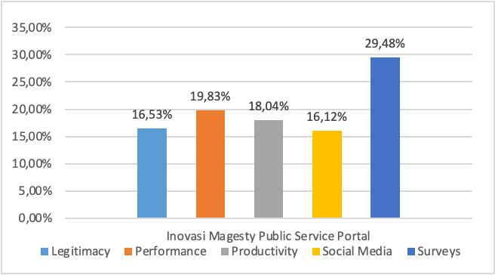
Figure 2. Magesty Public Services Portal Innovation Assessment
The Magesty Public Services Portal (MPSP) benefits users and owners, enhancing task efficiency and addressing public service access challenges. Users experience cost and time savings compared to conventional methods, promoting increased engagement. Notably, the MSME shopping feature fosters collaboration between MSME players and buyers, influencing product variety and quality on the app. For the Regional Device Organization (OPD-Organisasi Perangkat Daerah), user engagement is measured through registered users and transactions on the Magesty App, indicating its recognition among Magelang City residents.
A public satisfaction survey by the Magelang City Government in 2023 attests to the MPSP's positive impact, with an 85% satisfaction rate, marking a 15% increase from 2022. This success results from improved accessibility, faster, more accessible, transparent public services, and enhanced administrative processes. The MPSP's positive response is evident in public testimonials, highlighting its substantial contribution to Magelang City's public service landscape.
"MPSP helps me to get public services. I no longer need to come to the public service office to process documents. I need to do it online."
"Public service in Magelang City has become better after the MPSP. Services are faster, easier, and more transparent."
"I am delighted with the MPSP implementation. This innovation has made it easier for people to get public services."

The Magelang City Government aims to enhance the Magesty Public Services Portal (MPSP) by increasing the number of online services, improving quality, and boosting public promotion. Despite its positive impact on the community and government responsiveness, the MPSP's performance percentage is relatively low at 19.83%. The primary obstacle lies in technical challenges from insufficient human resources for the app's development. Overcoming this hurdle is crucial for maximizing the Magesty App's potential. Additionally, supporting infrastructure needs improvement to align with the growing user base and application frequency.
The Magesty App has significantly benefited users, providing efficiency, cost savings, and time efficiency in accessing public services compared to conventional methods. Despite obstacles, the innovation addresses community needs, making public services more accessible and cost-effective, ultimately improving Magelang City residents' overall quality of life. Continued efforts in development and infrastructure enhancement are essential to overcoming existing challenges and further maximizing the positive impact of the Magesty App.

Innovation of Plaza Tani Magelang City
Pelataran Serba Ada Produk Pertanian (Plaza Tani) is a unique public service innovation implemented by the Agriculture and Food Service Office of Magelang City. Unlike many modern innovations focusing on digital technology, Plaza Tani is an example of successful non-digital innovation within this work unit. The innovation was designed with two target user groups: the State Civil Apparatus (ASN) of the Magelang City Government and the wider community. For the ASN of the Magelang City Government, Plaza Tani provides a unique opportunity to support the development of the local agricultural sector. They can contribute by becoming facilitators in organizing Plaza Tani, connecting local farmers and producers with consumers, and promoting agribusiness sustainability in the city. As a pillar of public service, ASN has a crucial role in ensuring the sustainability and effectiveness of this innovation.
Meanwhile, the community is another user group that benefits from the Plaza Tani innovation. The community can directly access high-quality local agricultural products, support local producers, and reduce the time and cost usually associated with obtaining agricultural products (Leng et al., 2018). Plaza Tani creates opportunities for the community to actively participate in developing a sustainable agricultural sector and contribute to the local economy.
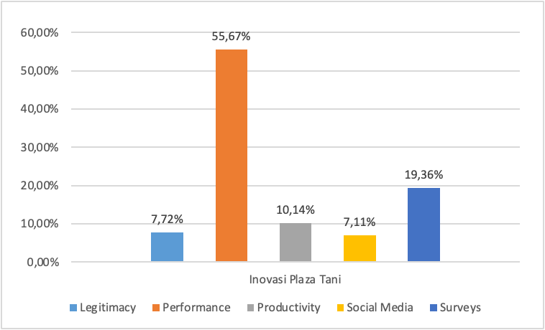
Figure 3. Plaza Tani Innovation Assessment
The research reveals a commendable 55.67% performance for the Plaza Tani innovation, showcasing its effectiveness in facilitating the marketing of agribusiness products in Magelang City. Plaza Tani offers affordable, quality agricultural, livestock, fishery, and processed food products, minimizing the risk of damage before consumption or marketing. The synergy between Magelang City Disperpa, other OPDs, and the community contributes to Plaza Tani's success, held every Friday from 7:00 a.m. to 11:00 a.m. This flexible operational time fosters efficient interactions and transactions between local producers and citizens.
The innovation has garnered a highly positive public response, with a notable 80% satisfaction rate, reflecting an impressive 10% increase from the previous year's survey. The key factors contributing to this satisfaction include increased accessibility, strict quality standards ensuring product quality and hygiene, economic benefits for local producers, and heightened public awareness of the importance of supporting local products. The positive community testimonials further validate Plaza Tani's impact and success in Magelang City.
"Plaza Tani helps me to get local products. I no longer need to go to the market to look for local products. I can just come to Plaza Tani."
"Local products sold at Plaza Tani have good quality and affordable prices. I am delighted with the implementation of Plaza Tani."
"I am delighted with the implementation of Plaza Tani. This innovation has made it easier for people to get local products."
Plaza Tani in Magelang City has successfully addressed local product accessibility challenges, improving product quality, affordability, and community awareness. Despite its success, various obstacles hinder its development and operation at both macro and micro levels. A limited budget poses a macro-level challenge, hindering the modernization and efficiency improvement of Plaza Tani. Restricted accessibility and awareness among residents also impact visitor numbers—more facilities, including tents, fans, freezers, and promotional materials, present hurdles. Production limitations and the need for continuous supply must be addressed through collaboration with surrounding groups. Micro-level constraints involve suboptimal empowerment of Disperpa's assistants and packaging inconsistencies. Additional concerns include competitive pricing, modernizing the marketing system, and efficient supply management after operational hours. Collaborative efforts involving the Magelang City Government fostered groups, and related parties are essential to address these challenges, emphasizing increased budget, improved promotion, standardized packaging, competitive pricing, and efficient supply management for Plaza Tani's sustained success in providing quality public services to the community.
Innovation Contribution and Sustainable Impact
The Magesty Public Service Portal (MPSP) in Magelang City has significantly contributed to public services and created sustainable impacts for the community and the city government. This innovation not only brings positive changes in public services but also impacts various aspects of people's lives and the city's overall development.
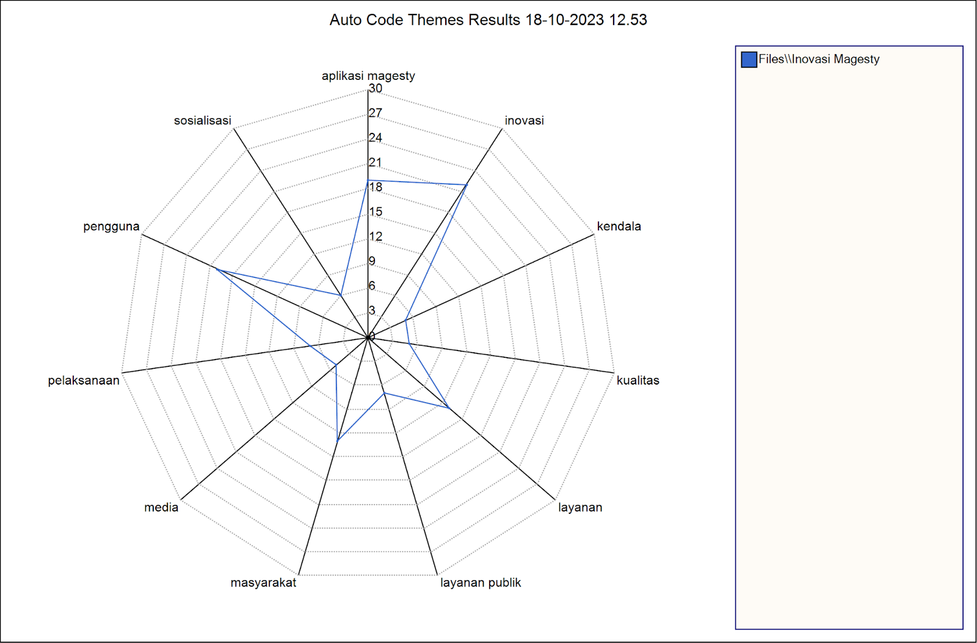
Figure 4: Analysis of the Contribution and Sustainable Impact of Magesty Public Service Portal (MPSP)
Figure 4 shows that MPSP innovation in Magelang City positively impacts sustainability. Despite implementation issues, MPSP has the potential for speedier, more efficient, and transparent public services. Online platforms improve public service accessibility for residents outside the city or with limited mobility. Online licensing, including commercial and environmental licenses, saves time and optimizes government resources. MPSP revolutionizes population administration by providing online KTP, KK, and birth certificate access. Service speed and transparency improve. Online help applications improve social services' accessibility and openness. MPSP overcomes geographical and physical barriers to enhance social inclusion.
Magelang City's MPSP commitment to efficiency and transparency shows how information technology may alter public services. Local expansion, especially in Plaza Tani, boosts farmer and producer income. Sales boost the local economy and create jobs. MPSP's positive changes demonstrate the digital era's revolutionary potential, increasing community quality of life and promoting sustainable economic growth. MPSP's optimization and long-term profitability depend on online service development and quality improvements.
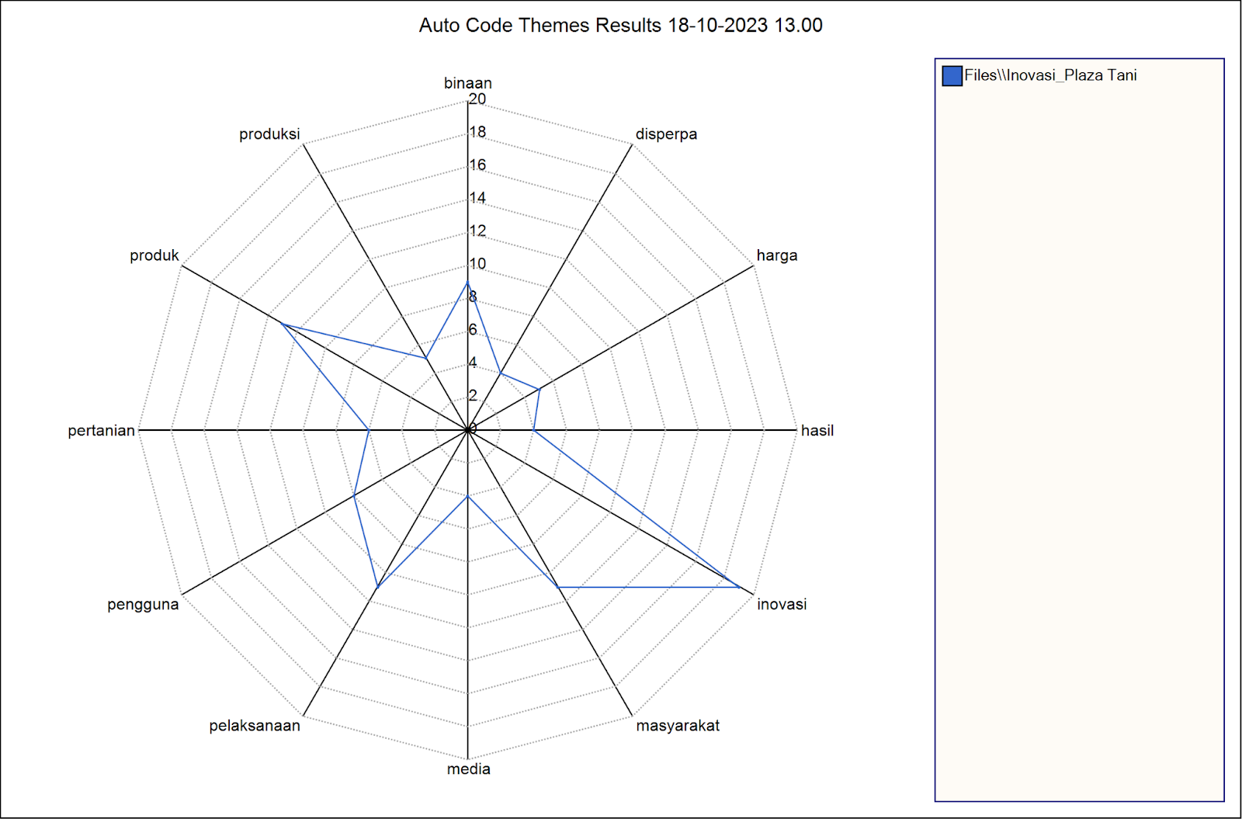
Figure 5: Analysis of Innovation Contribution and Sustainable Impact of Plaza Tani Innovation
Figure 5 illustrates the research analysis measuring the contribution and sustainable impact of the Plaza Tani innovation in Magelang City. The results highlight that Plaza Tani significantly enhances the welfare of the residents by providing easier access to high-quality local agricultural, livestock, and fishery products at more affordable prices. This innovation not only positively influences the local economy but also promotes community engagement, reinforcing community ties and empowering individuals to participate in the local economy actively.
The Plaza Tani innovation has increased the income of agribusiness actors, leading to improved welfare and better access to quality products for the people of Magelang City. The potential sustainable impacts include increased revenue for local farmers and ranchers, contributing to improved food security by encouraging higher production. Additionally, Plaza Tani fosters public awareness of the importance of supporting local products, benefiting the local economy and agribusiness actors.
To realize sustainable impacts, the Magelang City Government must continue to develop Plaza Tani by increasing participation, promoting actively to the community, enhancing product quality, and improving facilities. Integrating technology and online public services into Plaza Tani can further optimize its benefits. A dedicated mobile app can improve operational efficiency, allowing farmers to manage inventory, monitor sales, and interact with buyers. Secure electronic payment systems can streamline transactions, and online services can connect
Plaza Tani with relevant government agencies for more efficient licensing and regulation. Despite these advancements, it is crucial to ensure accessibility for all, including those with limited technology access, through training and support. A well-integrated Plaza Tani, technology, and online public services can enhance efficiency, transparency, and profitability, supporting the growth of the local agribusiness sector and overall welfare in Magelang City.

CONCLUSION
This research analyzes the transformative impact of the Magesty Public Services Portal and Plaza Tani innovation on public services and agribusiness marketing in Magelang City. Utilizing a mixed-method approach, combining qualitative and quantitative methods, the study reveals positive outcomes for the community and business actors.
The Magesty Public Services Portal enhances service quality and efficiency in public services, fostering increased community engagement. Plaza Tani, in the agribusiness context, serves as a physical space connecting producers directly with consumers, promoting local agricultural products, and contributing to agribusiness growth. Despite the positive impact, challenges surfaced, particularly in balancing technology and community participation. The study emphasizes the importance of community involvement in public service platforms and preserving direct producer-consumer interaction in Plaza Tani.
In conclusion, the research offers a comprehensive understanding of the effectiveness of public service transformation and its integration with agribusiness marketing. The practical implications guide policymakers, business actors, and the community to optimize digital transformation and innovative marketing for Magelang City's overall development. The research also suggests further technological and marketing strategies for future growth.

REFERENCES
Aggarwal, A. (2022). Special economic zones in the indonesia-malaysia-thailand growth triangle. research.cbs.dk. https://research.cbs.dk/en/publications/special-economic-zones-in-the-indonesia-malaysia-thailand-growth-
Aini, O. D. N., Fanani, L., & Afirianto, T. (2023). Evaluasi dan Perancangan Pengalaman Pengguna Aplikasi Mobile Kursus Public Speaking (Oberi App) menggunakan Metode Shadowing dan Design Thinking. Jurnal Pengembangan Teknologi …. https://j-ptiik.ub.ac.id/index.php/j-ptiik/article/view/12747
Arkana, N. (2018). Peningkatan adopsi inovasi sistem informasi agribisnis berbasis aplikasi di kampung hidroponik gang hijau asmat, Jakarta Selatan. Repository.Uinjkt.Ac.Id. https://repository.uinjkt.ac.id/dspace/handle/123456789/56772
Berman, E. M., Bowman, J. S., West, J. P., & Wart, M. R. Van. (2021). Human resource management in public service: Paradoxes, processes, and problems. books.google.com. https://books.google.com/books?hl=en&lr=&id=WSs0EAAAQBAJ&oi=fnd&pg=PT17&dq=public+service+accessibility&ots=KsSzuoQl07&sig=rb_tFBHY84frW6VwfwdI_B_WYm8
Brandsen, T., Steen, T., & Verschuere, B. (2018). Co-production and co-creation: Engaging citizens in public services. library.oapen.org. https://library.oapen.org/handle/20.500.12657/25001
Darwis, V., Rachmawati, R. R., Muslim, C., Chanifah, & ... (2023). Transformation of financial institutions grants from the government to inclusive financial institutions in Indonesia. In Plos one. journals.plos.org. https://journals.plos.org/plosone/article?id=10.1371/journal.pone.0286482
Dayaram, K., Lambey, L., Burgess, J., & Afrianty, T. W. (2020). Developing the Workforce in an Emerging Economy: The Case of Indonesia. books.google.com. https://books.google.com/books?hl=en&lr=&id=vOfeDwAAQBAJ&oi=fnd&pg=PT8&dq=public+service+transformation+digitali+innovation+plaza+tani+regional+innovation+agribusiness+marketing&ots=FMDHiDg7vM&sig=qb-s8Z6qqeJp-oCXYM1qpj5fVfI
Eldo, D., & Mutiarin, D. (2018). Analisis Best Practice Inovasi Pelayanan Publik (Studi pada Inovasi Pelayanan “Kumis MbahTejo” di Kecamatan Tegalrejo Kota Yogyakarta). Jurnal Manajemen Pelayanan Publik. http://jurnal.unpad.ac.id/jmpp/article/view/16753
Fauziah, N. M., & Mahendradi, R. M. (2021). Dinamika Kebijakan City Branding Kota Magelang: antara Preferensi Politik dan Evidence Based Policy. Jurnal Ilmu Administrasi …. https://jia.stialanbandung.ac.id/index.php/jia/article/view/634
Fauziyah, S. N. (2021). Pembuatan Sistem Informasi Puskesmas dengan Teknologi Quick Response Code Berbasis Web di Puskesmas Tamanan. sipora.polije.ac.id. https://sipora.polije.ac.id/7927/
Grimm, D. (2022). Against Regulatory Disruption. HeinOnline. https://heinonline.org/hol-cgi-bin/get_pdf.cgi?handle=hein.journals/juraba62&section=21
Hadiyono, W. C., Kurniaty, Y., & ... (2023). Analisa Penerapan Asas Umum Pemerintahan yang Baik dalam Pelaksanaan Pelayanan Publik Berbasis Online sebagai Inovasi Pelayanan Publik. Borobudur Law and …. https://journal.unimma.ac.id/index.php/blastal/article/view/9882
Hub, Q. F. T. (2021). From Qatar to the World: A report on the state of FinTech in Qatar (2021). openresearch-repository.anu.edu.au. https://openresearch-repository.anu.edu.au/bitstream/1885/278649/1/QatEcon_20.pdf
Hudaefi, F. A., & Beik, I. S. (2021). Digital zakāh campaign in time of Covid-19 pandemic in Indonesia: a netnographic study. Journal of Islamic Marketing. https://doi.org/10.1108/JIMA-09-2020-0299
Hutagalung, S., & Hermawan, D. (2019). Merancang Program Inovasi Berkelanjutan Di Propinsi Lampung. repository.lppm.unila.ac.id. http://repository.lppm.unila.ac.id/id/eprint/12197
Kesu, A. G. (2021). Inovasi Dalam Peningkatan Pelayanan Kependudukan Pada Dinas Kependudukan Dan Catatan Sipil Kabupaten Ende Provinsi Nusa Tenggara Timur. PRAJA Observer: Jurnal Penelitian Administrasi Publik. https://aksiologi.org/index.php/praja/article/view/96
LATIFAH, I. S. (2022). Peran Bappeda Dalam Mendukung City Branding Magelang Kota Sejuta Bunga (Mksb). dspace.uii.ac.id. https://dspace.uii.ac.id/handle/123456789/40951
Leng, K., Bi, Y., Jing, L., Fu, H. C., & ... (2018). Research on agricultural supply chain system with double chain architecture based on blockchain technology. Future Generation …. https://www.sciencedirect.com/science/article/pii/S0167739X18304527
Mergel, I., Edelmann, N., & Haug, N. (2019). Defining digital transformation: Results from expert interviews. In Government information quarterly. Elsevier. https://www.sciencedirect.com/science/article/pii/S0740624X18304131
Moseley, M. J. (2023). Accessibility: the rural challenge. books.google.com. https://books.google.com/books?hl=en&lr=&id=zf_KEAAAQBAJ&oi=fnd&pg=PA1940&dq=public+service+accessibility&ots=Fn0u0cnywQ&sig=l3drSP0cEGNbcJpmCslTOntjb8A
Nugraha, F., Agushinta, D., & Bastian, I. (2022). ANALISIS TINGKAT KEPUASAN PENGGUNA APLIKASI MYTELKOMSEL MENGGUNAKAN EVALUASI HEURSITIK DAN METODE PIECES (Studi Kasus …. In Jurnal Teknologi Informasi dan …. academia.edu. https://www.academia.edu/download/99701131/4403-25120-1-PB.pdf
Ostrom, V., & Ostrom, E. (2019). Public goods and public choices. Alternatives for Delivering Public Services. https://www.taylorfrancis.com/chapters/edit/10.4324/9780429047978-2/public-goods-public-choices-vincent-ostrom-elinor-ostrom
Pramono, R. W. D. (2020). Evaluasi Dan Perencanaan Pembangunan Wilayah Dengan Pendekatan Kapabilitas. books.google.com. https://books.google.com/books?hl=en&lr=&id=DorwDwAAQBAJ&oi=fnd&pg=PP1&dq=aksesibilitas+evaluasi+inovasi+pelayanan+publik+kota+magelang&ots=PAln3KIkXH&sig=PEXDEQ1vqGmVotBwArqHVmtBUHI
Prasetyo, A., & Arifin, M. Z. (2018). Pengelolaan Destinasi Wisata yang Bekelanjutan dengan Sistem Indikator Pariwisata. books.google.com. https://books.google.com/books?hl=en&lr=&id=fNFTDwAAQBAJ&oi=fnd&pg=PP1&dq=aksesibilitas+evaluasi+inovasi+pelayanan+publik+kota+magelang&ots=gkOm2eBRa8&sig=QX2wCJ61niJJ64P8EvAtiE-lYG4
Prastya, Y. R., & Sunaningsih, S. N. (2020). Analisis Penerapan Program Inovasi Pada Disdukcapil Kota Magelang Tahun 2020. Jurnal Ilmu Administrasi Negara …. http://ojs.umrah.ac.id/index.php/juan/article/view/2686
Prayitno, G., & Subagiyo, A. (2018). Membangun desa: Merencanakan desa dengan pendekatan partisipatif dan berkelanjutan. books.google.com. https://books.google.com/books?hl=en&lr=&id=c-qEDwAAQBAJ&oi=fnd&pg=PA54&dq=transformasi+pelayanan+publik+inovasi+digitali+plaza+tani+inovasi+daerah+pemasaran+agribisnis&ots=AhaVl8x3bz&sig=3R5wAlQK4icJ2SFU1EwXxR8QEps
Rossolatos, G. (2019). Negative brand meaning co‐creation in social media brand communities: A laddering approach using NVivo. Psychology & Marketing. https://doi.org/10.1002/mar.21273
Salahudin, S., Nurmandi, A., & ... (2020). How to Design Qualitative Research with NVivo 12 Plus for Local Government Corruption Issue in Indonesia? … OF GOVERNMENT & …. https://eprints.umm.ac.id/97995/
Setthasuravich, P., & Kato, H. (2020). The mediating role of the digital divide in outcomes of short-term transportation policy in Thailand. Transport Policy. https://www.sciencedirect.com/science/article/pii/S0967070X20302481
Stępniak, M., Pritchard, J. P., Geurs, K. T., & ... (2019). The impact of temporal resolution on public transport accessibility measurement: Review and case study in Poland. In Journal of transport …. Elsevier. https://www.sciencedirect.com/science/article/pii/S0966692318305209
Swygart-Hobaugh, M. (2019). Bringing method to the madness: An example of integrating social science qualitative research methods into NVivo data analysis software training. Iassist Quarterly. https://iassistquarterly.com/index.php/iassist/article/view/956
Tsabita, A. N. I. (2021). … PROGRAM SI SAKTI DALAM KEPEMILIKAN AKTA KEMATIAN DI DINAS KEPENDUDUKAN DAN PENCATATAN SIPIL KOTA MAGELANG PROVINSI JAWA TENGAH. eprints.ipdn.ac.id. http://eprints.ipdn.ac.id/6093/
Türkeș, M. C., Stăncioiu, A. F., Băltescu, C. A., & ... (2021). Resilience innovations and the use of food order & delivery platforms by the romanian restaurants during the covid-19 pandemic. In Journal of Theoretical …. mdpi.com. https://www.mdpi.com/0718-1876/16/7/175
Twizeyimana, J. D., & Andersson, A. (2019). The public value of E-Government–A literature review. In Government information quarterly. Elsevier. https://www.sciencedirect.com/science/article/pii/S0740624X1730196X
Walia, S. K. (2020). The Routledge Handbook of Community Based Tourism Management: Concepts, Issues & Implications. books.google.com. https://books.google.com/books?hl=en&lr=&id=rwsLEAAAQBAJ&oi=fnd&pg=PP1&dq=public+service+transformation+digitali+innovation+plaza+tani+regional+innovation+agribusiness+marketing&ots=QNTjkFnzUr&sig=1j97Rz3llwXNNWKT1KkXt0K22Ak
Wang, M., & Zhou, C. (2023). How Does Graduate Training Promote Sustainable Development of Higher Education: Evidence from China’s “Double First-Class” Universities’ Programs. Sustainability. https://www.mdpi.com/2071-1050/15/2/944
Yunani, A. (2022). Isu-Isu Perencanaan Pembangunan (Teori Dan Praktek). repo-dosen.ulm.ac.id. https://repo-dosen.ulm.ac.id/handle/123456789/25486
Zhang, Q., Chen, W., & Ling, W. (2022). Policy optimization of hydrogen energy industry considering government policy preference in China. Sustainable Production and Consumption. https://www.sciencedirect.com/science/article/pii/S2352550922002238

